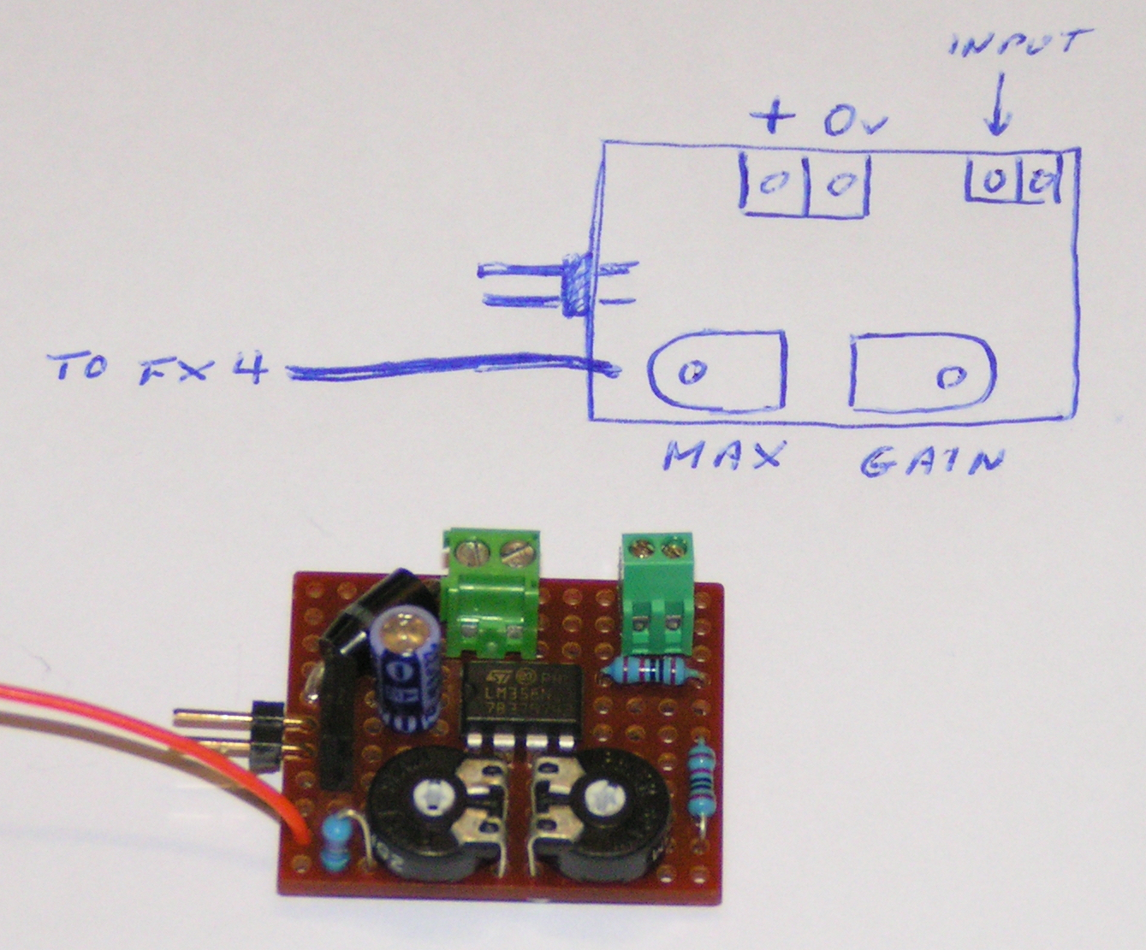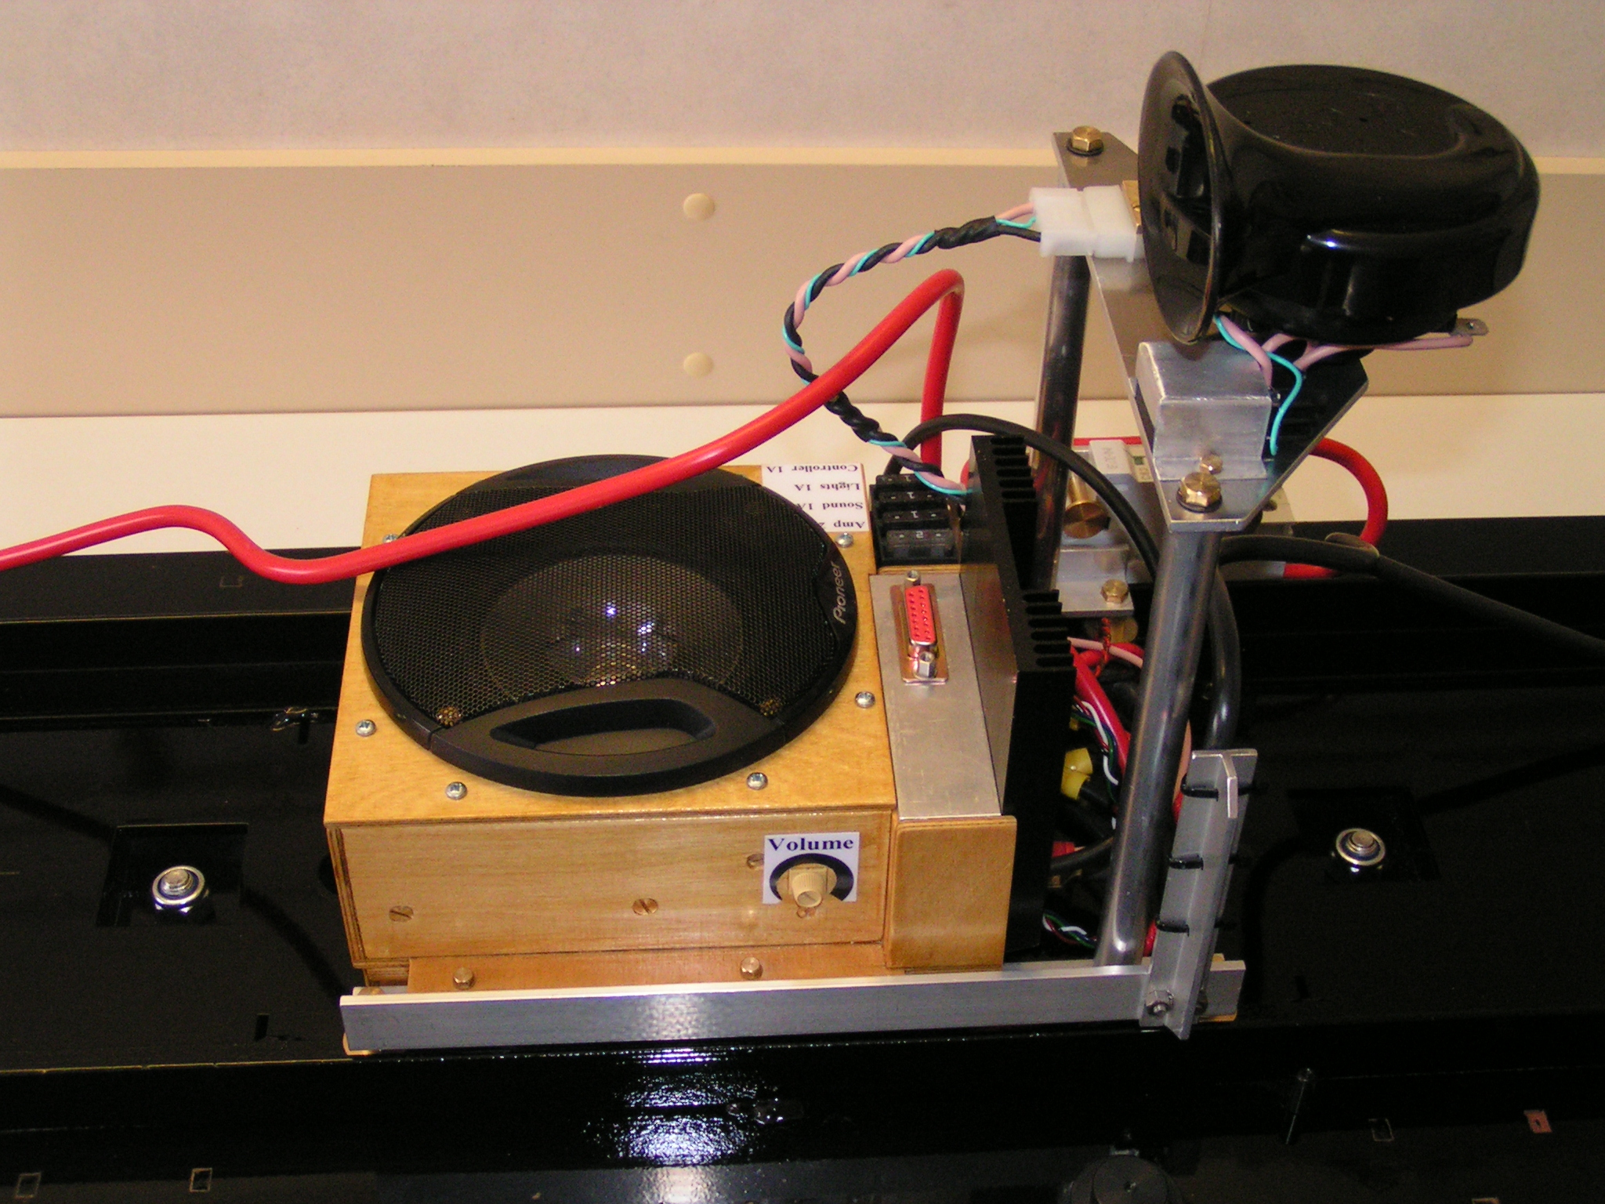
The wiring diagram on the first page shows the entire circuit diagram for the sound system as installed in my Hercules including the interface module that was required to enable the FX4 sound unit from Brian Jones to be controlled from the 4QD speed controller supplied with the loco by Ride on Railways. This module is required because the normal interface module supplied by Brian (at the time of building my Hercules in 2007) resulted in the engine noise being at top speed when the model was stopped, and vice versa. It's not difficult to build if you understand basic electronics and soldering, so it's up to you to decide if you can cope.

The two potentiometers allow the maximum simulated engine speed, and setting of the model loco's speed control at which this simulated speed is reached, to be adjusted. On my Hercules I set it so that the maximum simulated engine speed was reached at just over half loco speed. This gave a very nice rapid simulated engine speed build up as the loco moved slowly away at a station, which to me at any rate is more realistic.

On the wiring diagram there are 4 wires shown at the "Audio In" position. These are connected as follows:
Blue = Connects to the blue wire from the 4QD speed potentiometer wire of the hand controller
Black = 0 Volts (of the battery supply)
Yellow = +24 Volts from the switched side of hand controller On / Off switch
Pink = +18 Volt d.c. amplifier supply.

A point to note is that the KEMO amplifier is designed to operate at a maximum of 18 Volts, so it was fed from the locos 24 Volt battery system via a voltage stabiliser (another home design). I know that many modellers simply run these amplifiers from the full 24 Volts, but this may be why so many of them see their amplifiers "burn out". You can make up your own mind on this point.

The photo of the assembled loco shows how the sound system was installed in the Hercules using a small plywood box about 120mm square. The box was purpose built to just fit around the 4" Panasonic car speaker, with just enough space to also fit the FX4 and interface modules inside it. The 18 Volt regulator, along with other circuits of the loco that needed a heatsink fits in the right side extension of the box against the black heatsink.

The important point to remember is that the sound will seem much better when the speaker is properly mounted in a box. Leaving the speaker with both sides open in free air will not produce a very good sound effect.

Brian Jones sound modules, with various different recordings of "real" locomotives can be found at http://www.brianjones.free-online.co.uk

